 COSC 2320
Name: _________________ Terminal #__

Estimated Hours 1
Actual Hours

TA (Textual Analysis) for UML USE CASE Diagram MODEL
Programming Assignment 3:
(10 points)
(Due date found in the COSC 2320 BB Calendar!)
You must use Microsoft WORD program. Insert the TEMPLATEs for Actors and Use Cases in this Requirements Document.

Please have Step 1, 2, 3, and 4 in this order.

Requirements Analysis: Construct the UML Use Case Diagram MODEL

Hash Table - Chaining - Cell Phone Contact List Application
ProgrammingAssignment3 APPLICATION
A cell phone manufacturer would like a Java program (Using MVC classes, design an ProgrammingAssignment3 APPLICATION) that maintains the list of contacts for a cell phone owner. For each contact, a person’s name, there should be a list of phone numbers that can be changed. The manufacturer desires an interface for the software (ContactListInterface and ContactList Class).

- addOrChangeEntry( String name, List< String> numbers)

Changes the numbers associated with the given name or adds a new entry with this name and list of numbers. Returns the old list of numbers or null if this is a new entry.

- lookupEntry( String name)
Searches the contact list for the given name and returns its list of numbers or null
if the name is not found.

- removeEntry( String name)
Removes the entry with the specified name from the contact list and returns its list of numbers or null if the name is not in the contact list.

- display();
Displays the contact list in order by name.

A hash table Class is an ideal data structure for the contact list. It will associate names (which are unique) to lists of phone numbers. Therefore, the name is a key field and the list of phone numbers “is” the value field.

Sample entries would be:

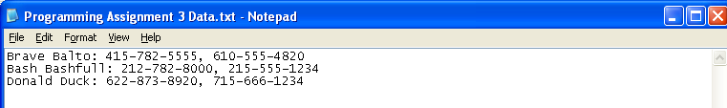

Create a ProgrammingAssignment3.java that contains the main method.
PLEASE DO NOT INCLUDE THESE PAGES AS YOUR DELIVERABLES! This is just for your use. Please have Step 1, then 2, etc. order in your deliverables.

UML LANGUAGE THAT MUST BE USED FOR TEXTUAL ANALYSIS!!!

UML USE CASE DIAGRAM MODELING:

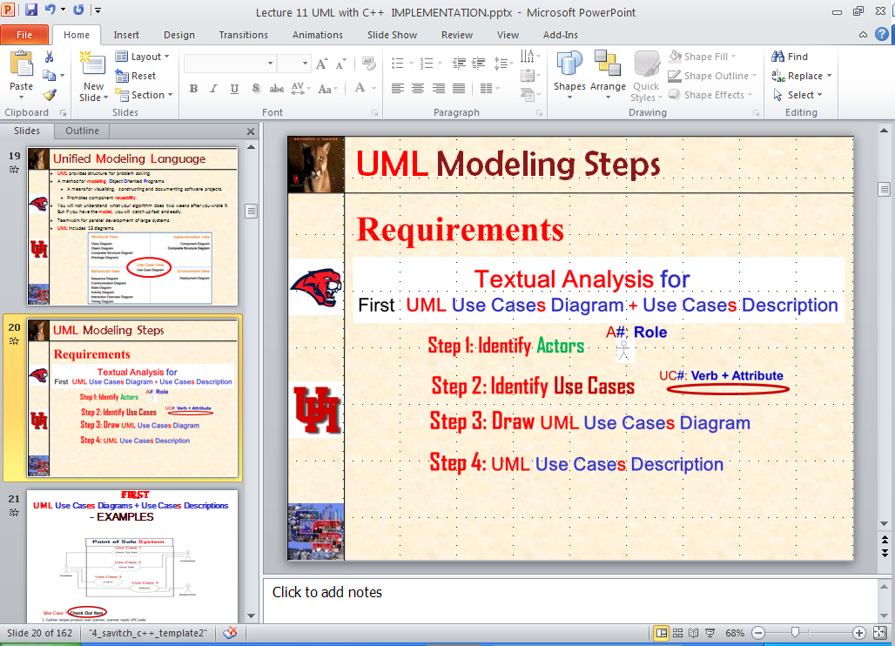

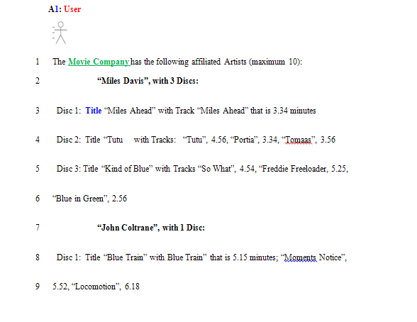

SEMANTICS: Actor #: Label
# is replaced by 1, 2,.
Label is a (first letter Upper Case) Role.

UML LANGUAGE:

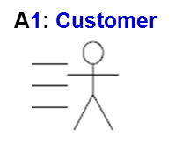 Number is 1 and Label is Customer (Upper Case C)
TEMPLATE:
A1: Customer
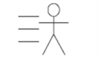

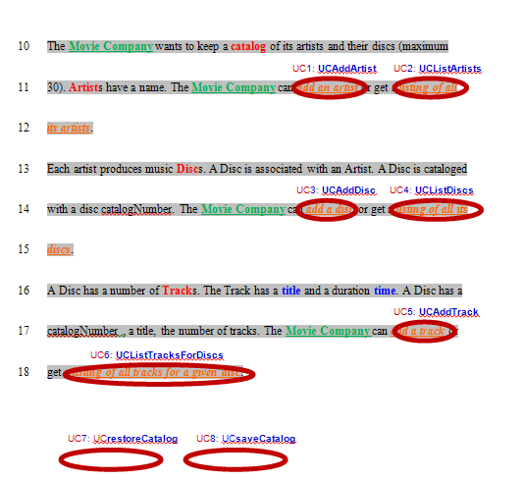

SEMANTICS: UC #: Label
# is replaced by 1, 2,.
Label is a (first letter Upper Case) Action Verb + Descriptive Attribute.



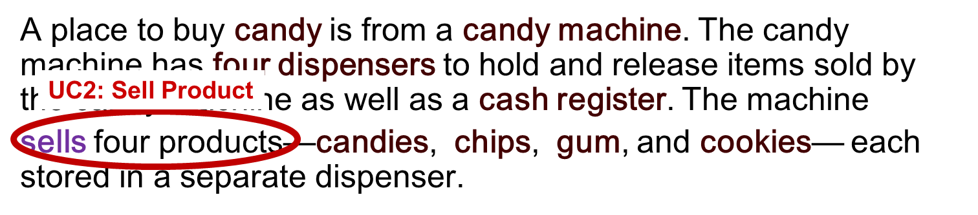
TEMPLATE:
UC#: Verb + Attribute

